www.buffalosoldiersresearchmuseum.org
Buffalo Soldiers Research Museum Newsletter
April 2008
Volume 6 - Issue 2
Published four times each year ~ January, April, July & October

The American Civil War and Black Americans (1861-65)
Our Journey

When I discovered the story of black soldiers who enlisted in the U.S. armed forces after the Civil War with the 38th, 39th, 40th and 41st Infantry Regiments and the 9th & 10th Horse Cavalry Regiments, I was hooked. This was the perfect research project for me. In the 1990’s, I lived in Fredericksburg, VA where 4 or 5 Civil War battles were fought but I was not interested in that period. The story of the Buffalo Soldiers would take me to the west. As a teenager, I watched westerns on television. This was where I wanted direct my research efforts. That was my mind-set as we traveled from Virginia to Ohio. Now it is 2008.
Now I’m ready to back-track to the Civil War and take a closer look. After years of researching the Buffalo Soldiers (1866-1944), it is important to put their story in context. What happen before Congress authorized these all-black units on July 28, 1866? How many black soldiers from the Civil War joined these units? How many white officers served with them? What were their motivations –both soldiers and officers?
We continued to travel west from Ohio to Indianapolis where we met Andrew Bowman. His grandfather, Andrew Jackson Smith, posthumously received the Medal of Honor for actions during the Civil War. Smith enlisted in the 54th Massachusetts Infantry (depicted in the move Glory). This unit was full so he joined the 55th U.S. Colored Troops. At the battle of Honey Hill, South Carolina on November 30, 1864, Smith’s unit charged the Confederate position. The white officer leading the troopers and the Sergeant carrying the regimental colors were killed. Smith grabbed the flag and carried it against heavy close range fire. The Department of the Army stated that the actions showed conspicuous valor since the flag inspired hope and courage to sustain the fight. On June 21, 2000, President Bill Clinton awarded the Medal of Honor to the Bowman family. In an interview with Andrew Bowman, he said that it was a long time coming.

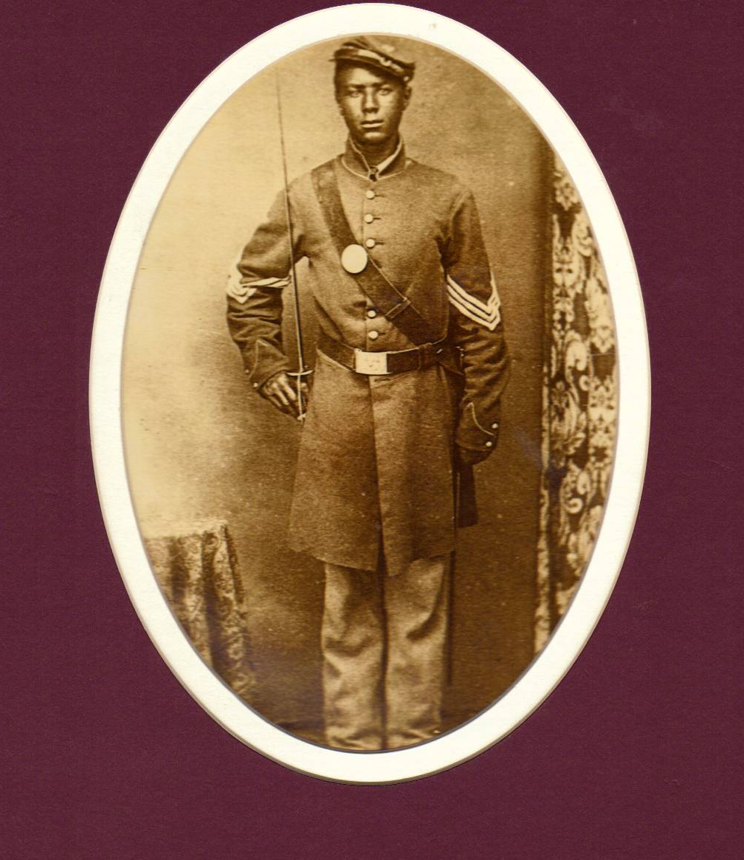
Andrew Jackson Smith
Civil War Soldier
(pictured at left)

The Department of Defense held a ceremony at the Pentagon for the families whose loved one would receive the Medal of Honor. Bowman provided the Buffalo Soldiers Research Museum a video for the Pentagon’s ceremony.
In August 2004, a ceremony was conducted on the Monument Circle in the heart of Indianapolis to dedicate a historical marker for the U.S. Colored Troops 28th Regiment. The mayor, civic leaders, citizens, and descendents of Civil War veterans were there. Andrew Bowman and others were dressed in Civil War uniforms. The marker was mounted near the location where the regiment’s initial training took place on the south side of Indianapolis in a neighborhood called Fountain Square. During an interview with Bowman, he said that he paid for the historical marker with his own funds.

The American Civil War (1861-1865) was well under way when President Lincoln signed the Emancipation Proclamation in 1863. Under paragraph six, blacks where officially allowed to enlist in the U.S. Regular Army. Indiana blacks wanted to serve and fight for the Union and they did. They were the 28th Regiment, U.S. Colored Troops (USCT). In 1816, Indiana prohibited slavery in its state constitution and according to the U.S. Census of 1816, there were 11,428 persons of African descent in the state. The Bureau of United States Colored Troops credited Indiana with 1,537 enlistees as of March 1865.

Organized at Indianapolis from December 24, 1963 to March 31, 1864, the 28th Regiment, U.S. Colored Troops was the only African American regiment in Indiana. Its initial training took place at Camp Fremont located near the Fountain Square neighborhood in Indianapolis. The regiment’s commanding officer was Captain Charles S. Russell.
On April 24, 1864 the 28th was sent to Washington, DC and then to Alexandria, VA for future training. Near White House, Virginia, on June 21, 1864, the 28th Regiment participated in its first combat. Then the regiment accompanied General Sheridan’s Cavalry through the Chickahominy swamps to Prince George Courthouse suffering “servere losses from frequent skirmishes with the enemy”.

The regiment then participated in the siege operations around Petersburg and Richmond from July 1864 through the beginning of April, 1865. They were engaged in battles at the “Crater” on July 30, 1864; the Weldon Railroad on August 18-21, 1864; Poplar Grove Church on September 29 - October 1, 1864: Boydton Plank Road, Hatcher’s Run on October 27-28, 1864 and they marched into Richmond on April 4, 1865. More specifically, the Battle of the Crater on July 30, 1864 was significant. The siege of Petersburg was a long, bitter and wearying struggle. On June 3, General Grant had begun to dig in. On June 15, a Union attack failed, and the Federals-weary of their futile efforts-hatched an ingenious plot. Very early on the morning of July 30, along the eastern fortifications, a man crawled through a tunnel and lit a fuse. At 4:55 a.m. a heartening roar shook the Confederate fortifications. Men, earth and timber were hurled skyward. The Union soldiers had literally undermined the Confederate fortifications, tearing out smoking craters some 170 feet long, 60 to 80 feet wide and 30 feet deep. Triumphant, the Union soldiers poured in the hole they had blasted in the Confederate lines. But their mine had backfired. Once in the Crater, the confused and scrambling soldiers could not get out. More and more troops poured in upon the already struggling captives. The Confederates General Bushrod Johnson rallied quickly behind the pit. Their artillery zeroed in and began dropping shells. Too late, the North attempted retreat. By 1 p.m. on July 30 more than 4,00 union soldiers were killed, wounded, or captured, with soldiers from the U.S. Colored Troops suffering the heaviest losses.

At the war’s end, there was much unrest in the West, especially in Texas. The 28th Regiment, U.S. Colored Troops took up duty at Brazos, Santiago and Corpus Christi, Texas until November, 1865. The regiment was mustered out of the Army on November 8, 1865 with a public reception held in Indianapolis on January 8, 1866.

African American Civil War Memorial
Dedicated July 1998
Washington D.C.
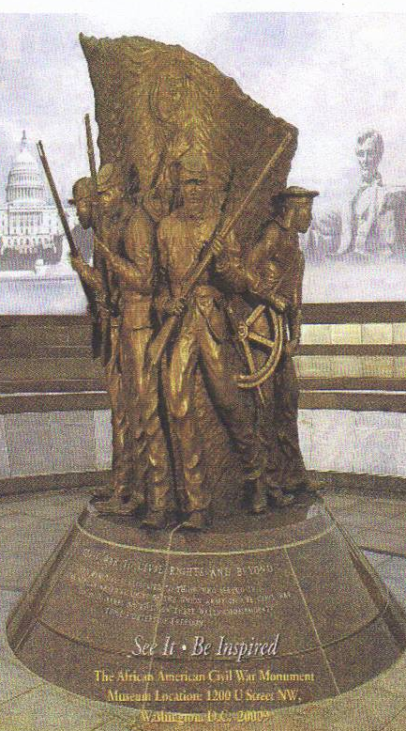
The African American Civil War Memorial honors black soldiers who fought for freedom during the American Civil War (1861-65). The Spirit of Freedom sculpture and its Wall of Honor serve as a reminder of the courageous story of the U.S. Colored Troops who helped end slavery and keep America united under one flag. The bronze sculpture portrays uniformed black soldiers and a sailor. It is situated in the center of a granite-paved plaza, encircled on three sides by the Wall of Honor. The wall lists the names of 209,145 soldiers including 7,000 white officers. The African American Civil War Memorial was authorized by Public Law 102-412(106 Stat. 2104), and approved by Congress on October 14, 1992. It is an outdoor exhibit open to the public at all times. A few blocks from the monument, is a small museum that serves as the office for the founding director, Dr. Frank Smith and his staff. This is the only national monument dedicated to the U.S. Colored Troops. The Monument lists the names of each regiment with the names of each soldier. The 28th is engraved on Memorial Plaque number B-43 with all the soldiers’ names of the regiment.

For more information ~ contact

Buffalo Soldiers Research Museum
P.O. Box 531187
Indianapolis, IN 46253

www.buffalosoldiersresearchmuseum.org

